Dictionary Methods
Dictionary uses several built-in methods for manipulation.They are listed below
update()
The update() method updates the value of the key provided to it if the item already exists in the dictionary, else it creates a new key-value pair.
Example:
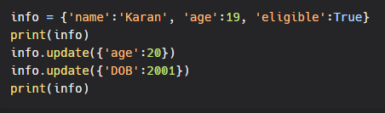
Output:
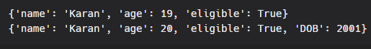
Removing items from dictionary:
There are a few methods that we can use to remove items from dictionary.
clear():
The clear() method removes all the items from the list.
Example:
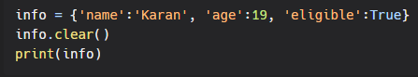
Output:
{}

pop():
The pop() method removes the key-value pair whose key is passed as a parameter.
Example:
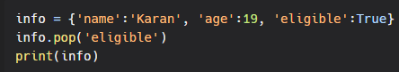
Output:
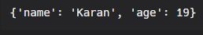
popitem():
The popitem() method removes the last key-value pair from the dictionary.
Example:
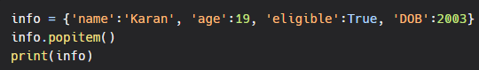
Output:
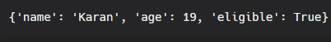
del:
we can also use the del keyword to remove a dictionary item.
Example:
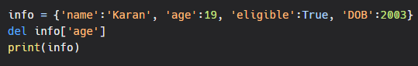
Output:
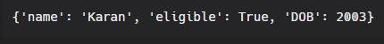
If key is not provided, then the del keyword will delete the dictionary entirely.
Example:
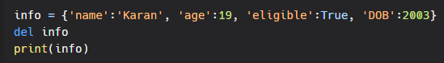
Output:


